NGUTUWERA SHIELD BATTLE!
Wednesday night saw a battle ensue as four teams from each club fought for the much coveted shield. The local derby match has been ongoing for many years and is named after the stream that crosses the boundaries halfway between them. This year Tokoroa were in fine form and came out victorious with four of their pairings finishing in the top 5. Congratulations Tokoroa and enjoy the title for a year. Putaruru will be back in pursuit in 2015.
Local Waikato Bays Regional Council member Jan Spaans was guest director tonight and ran the event with Bridgemates. Cambridge Bridge Club had kindly dealt and provided boards for the teams event and Jane Stearns from that club launched the “Spirit of South Waikato” photo competition. A wonderful spread ended the evening and the players went home to examine their results for the first time on the X-Club website.
Ngutuwera Stream
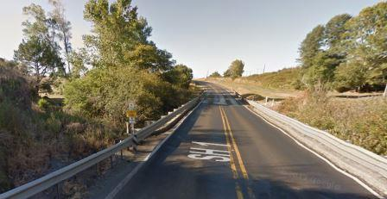
Photos of the event. The President of Putaruru is Eileen Barker and the President receiving the shield is Graeme Farrow.
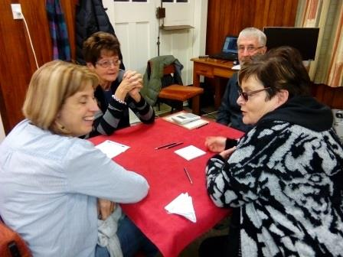 | 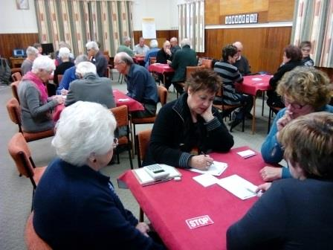
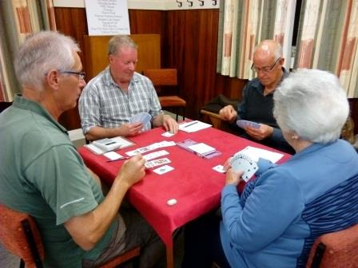 | 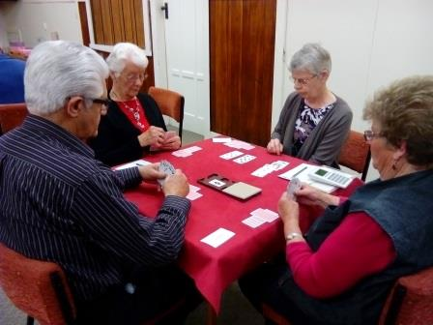
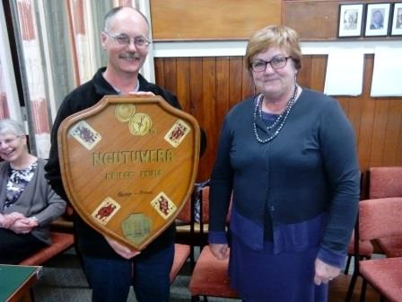 | 